Lab 5: Electrochemistry, Potentiometric Titrations, and Solubility Equilibria

Data Analysis

Part A
Q1. Create a plot of $E_{cell}$ versus $log(1/[Ag^{+}])$. Include your line of best fit and $R^{2}$ on the plot. Properly format the plot and include a descriptive figure caption below your figure. Explicitly write out how the line of best fit equation relates to the Nernst equation and your experimental Nernst equation.
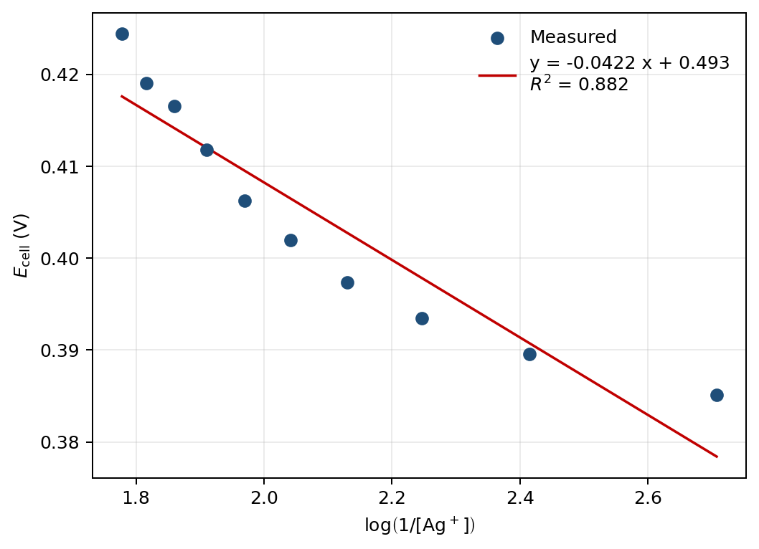
Figure 1. $E_{cell}$ vs. $log(1/[Ag^{+}])$ for the Part A Nernst calibration; linear fit (red) gives the slope and intercept reported in Q2 and Q4.
Line of best fit:
$$E_{cell}=-0.04215 log​\left(1/{[Ag^{+}]}\right)+0.4925 V.$$
The Nernst equation for Ag$​^{+}$ + e$​^{-}$ $→$ Ag(s) (manual eq. 8, $n=1$) is
$$E_{cell}=\left(E_{Ag^{+}/Ag}^{∘}-0.307\right)-\frac{0.05916}{n}log​\left(1/{[Ag^{+}]}\right),$$
so slope $↔-0.05916/n$ and intercept $↔E_{Ag^{+}/Ag}^{∘}-0.307$. The line of best fit is itself the experimental Nernst equation.

Q2. Determine the slope from the linear fit and report it with the appropriate 95% CI. Use appropriate significant figures and don’t forget units.
From the LINEST regression on the 10 points ($n=10$, df = 8, $t_{0.025,8}=2.306$):
$$\text{slope}=-0.04215 V/dec, SE_{\text{slope}}=0.00545 V/dec.$$
$$95\% CI=t⋅SE=2.306×0.00545=0.0126 V/dec.$$
$$\boxed{\text{slope}=-0.04±0.01 V/dec}$$

Q3. What is the theoretical number of electrons required in this half reaction at the indicator electrode? Calculate the experimentally determined number of electrons in this half reaction. Show your work.
The indicator half-reaction is Ag$​^{+}$ + e$​^{-}$ $→$ Ag(s), so $n_{\text{theoretical}}=1$.
From Q2, the slope magnitude is $0.05916/n$:
$$n_{\text{experimental}}=\frac{0.05916}{|\text{slope}|}=\frac{0.05916}{0.04215}=1.40.$$
Propagating the slope uncertainty:
$$σ_{n}=n⋅\frac{σ_{\text{slope}}}{|\text{slope}|}=1.40×\frac{0.00545}{0.04215}=0.182,$$
$$95\% CI(n)=t⋅σ_{n}=2.306×0.182=0.42.$$
$$\boxed{n_{\text{experimental}}=1.4±0.4}$$

Q4. Determine the y-intercept from the linear fit and report it with the appropriate 95% CI. Use appropriate significant figures and don’t forget units.
From the LINEST regression:
$$\text{intercept}=0.49254 V, SE_{\text{intercept}}=0.01148 V.$$
$$95\% CI=2.306×0.01148=0.0265 V.$$
$$\boxed{\text{intercept}=0.49±0.03 V}$$

Q5. Calculate $E_{Ag^{+}/Ag}^{∘}$ from your intercept value. Be sure to use propagation of error to calculate the appropriate 95% CI. Compare your $E_{Ag^{+}/Ag}^{∘}$ value to the literature value for the standard reduction potential of silver from the CRC Handbook value using a percent error. Show your work.
Solving the intercept relation $b=E^{∘}-0.307$ for $E^{∘}$:
$$E_{Ag^{+}/Ag}^{∘}=b+0.307=0.492542+0.307=0.799542 V.$$
The constant 0.307 V (Cu/CuSO$​_{4}$ reference potential, treated as exact) does not contribute to the variance, so
$$σ_{E^{∘}}=σ_{b}=0.01148 V, 95\% CI=2.306×0.01148=0.0265 V.$$
$$\boxed{E_{Ag^{+}/Ag,\text{exp}}^{∘}=0.80±0.03 V}$$
CRC literature value: $E_{Ag^{+}/Ag,\text{lit}}^{∘}=0.7996$ V. Percent error using the full-precision experimental value:
$$\%\text{ error}=\frac{|E_{\text{exp}}^{∘}-E_{\text{lit}}^{∘}|}{E_{\text{lit}}^{∘}}×100\%=\frac{|0.799542-0.7996|}{0.7996}×100\%=0.0073\%≈0.007\%.$$

Part B
Q6. Using your data from the careful titration in Part B of 150 ppm NaCl, create an overlaid graph of voltage versus volume (titration curve) and the first derivative plot. Be sure to label all axes, the two curves a legend, and the equivalence point: (volume, voltage). Include a descriptive figure caption below your figure.
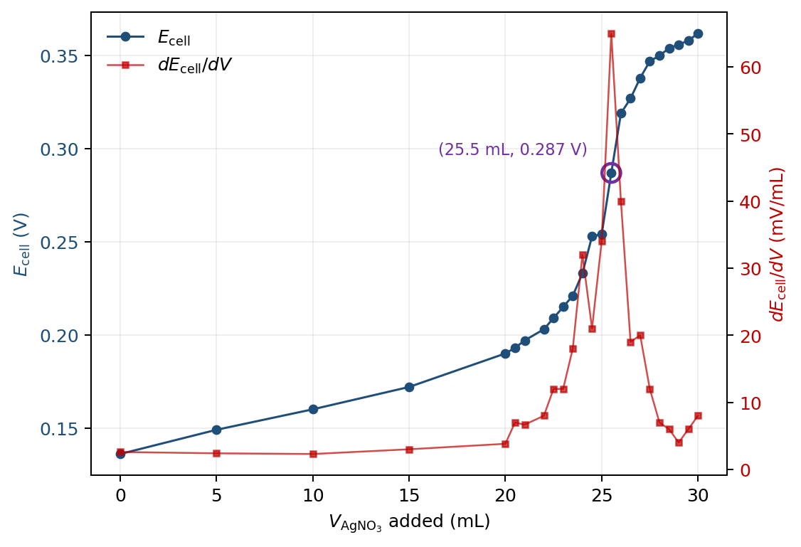
Figure 2. Potentiometric titration of 100.0 mL 150.2 ppm NaCl with 0.01000 M AgNO$​_{3}$. Cell potential (blue, left axis) and its first derivative (red, right axis); the equivalence point at the discrete maximum of $dE_{cell}/dV$ is circled.
Equivalence point read off the discrete maximum of $dE_{cell}/dV$ (central difference): $(V_{\text{eq}}, E_{\text{eq}})=(25.5 mL, 0.287 V)$.

Q7. Using the data from at least five groups of students of the careful titration of 150 ppm NaCl, calculate the average cell voltage at the equivalence volume and the 95% CI. Use appropriate significant figures and don’t forget units. Show your work. (Note: Be sure to include your own cell voltage at the equivalence point from your answer to Q6.)
Only four groups (including mine) had submitted careful-titration data to the class spreadsheet by the worksheet deadline. The calculation below uses $n=4$ with $t_{0.025,3}=3.182$ instead of the requested $n=5$.
Group | $E_{\text{eq}}$ (V)
Stephen (mine, from Q6) | 0.287
Daniel & Wyatt | 0.274
Jazmin & Karen | 0.269
Group 4 | 0.292
$${\overset{‾}{E}}_{\text{eq}}=\frac{0.287+0.274+0.269+0.292}{4}=0.2804 V.$$
$$s=0.01073 V, SE=s/\sqrt{4}=0.00537 V.$$
$$95\% CI=t_{0.025,3}⋅SE=3.182×0.00537=0.017 V.$$
$$\boxed{{\overset{‾}{E}}_{\text{eq,B}}=0.28±0.02 V (n=4)}$$

Q8. Calculate the average $K_{\text{sp}}$ of AgCl and the 95% CI using the data from the five groups of students for the 150 ppm NaCl titration. Show your work and use appropriate significant figures.
Calculated using $n=4$ groups (see Q7) and the literature $E_{Ag^{+}/Ag}^{∘}=0.7996 V$.
At the equivalence point $[Ag^{+}]=[Cl^{-}]=\sqrt{K_{\text{sp}}}$, so manual eq. 15 simplifies to
$$E_{\text{eq}}=\left(E_{Ag^{+}/Ag}^{∘}-0.307\right)+\frac{0.05916}{2}logK_{\text{sp}}.$$
Solving for $K_{\text{sp}}$ at ${\overset{‾}{E}}_{\text{eq}}=0.2804$ V:
$$logK_{\text{sp}}=\frac{2\left({\overset{‾}{E}}_{\text{eq}}-E_{Ag^{+}/Ag}^{∘}+0.307\right)}{0.05916}=\frac{2(0.2804-0.7996+0.307)}{0.05916}=-7.174,$$
$$K_{\text{sp}}={10}^{-7.174}=6.7×{10}^{-8}.$$
95% CI propagation through the exponential:
$$σ_{logK_{\text{sp}}}=\frac{2}{0.05916}⋅CI({\overset{‾}{E}}_{\text{eq}})=33.81×0.017=0.58,$$
$$CI(K_{\text{sp}})=K_{\text{sp}}⋅ln(10)⋅σ_{logK_{\text{sp}}}=6.7×{10}^{-8}×2.303×0.58=9×{10}^{-8}.$$
$$\boxed{{\overset{‾}{K}}_{\text{sp,B}}=(7±9)×{10}^{-8} (n=4)}$$

Q9. Calculate the percent error between the experimental $K_{\text{sp}}$ of AgCl calculated from the 150 ppm NaCl titration and the theoretical value of the $K_{\text{sp}}$ of AgCl ($1.8×{10}^{-10}$). Show your work.
$$\%\text{ error}=\frac{|{\overset{‾}{K}}_{\text{sp,exp}}-K_{\text{sp,lit}}|}{K_{\text{sp,lit}}}×100\%=\frac{|6.7×{10}^{-8}-1.8×{10}^{-10}|}{1.8×{10}^{-10}}×100\%=37126\%≈4×{10}^{4}\%.$$
The $$370$$ offset is consistent with a junction potential at the Cu/CuSO$​_{4}$ frit shifting $E_{\text{eq}}$ above the ideal value.

Part C
Q10. Using your data from the careful titration in Part C of unknown [NaCl], create an overlaid graph of voltage versus volume (titration curve) and the first derivative plot. Be sure to label all axes, the two curves a legend, and the equivalence point: (volume, voltage). Include a descriptive figure caption below your figure.
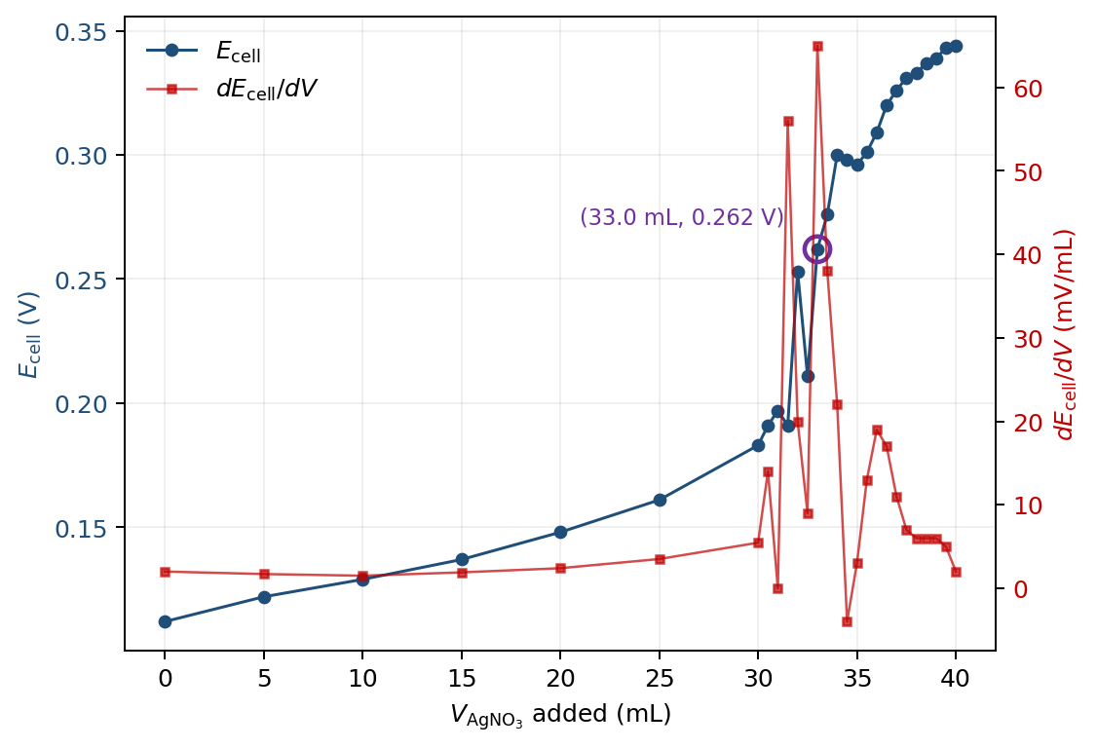
Figure 3. Potentiometric titration of 100.0 mL of an unknown NaCl solution (Part C) with 0.01000 M AgNO$​_{3}$. Cell potential (blue, left axis) and its first derivative (red, right axis); the equivalence point at the discrete maximum of $dE_{cell}/dV$ is circled.
Equivalence point: $(V_{\text{eq}}, E_{\text{eq}})=(33.0 mL, 0.262 V)$. Several points in the steep region (V = 31.5, 32.5, 34.5, 35.0) show transient negative $dE/dV$ from incomplete equilibration; the discrete-max location is reproducible from the .cmbl file.

Q11. Using the data from at least five groups of students of the careful titration of unknown [NaCl], calculate the average cell voltage at the equivalence volume and the 95% CI. Show your work. (Note: Be sure to include your own cell voltage at the equivalence point from your answer to Q10.)
Only three groups (including mine) had submitted careful-titration data for the unknown by the deadline. The calculation below uses $n=3$ with $t_{0.025,2}=4.303$ instead of the requested $n=5$.
Group | $E_{\text{eq}}$ (V)
Stephen (mine, from Q10) | 0.262
Jazmin & Karen | 0.277
Group 4 | 0.270
$${\overset{‾}{E}}_{\text{eq}}=\frac{0.262+0.277+0.270}{3}=0.2698 V.$$
$$s=0.00771 V, SE=s/\sqrt{3}=0.00445 V.$$
$$95\% CI=t_{0.025,2}⋅SE=4.303×0.00445=0.019 V.$$
$$\boxed{{\overset{‾}{E}}_{\text{eq,C}}=0.27±0.02 V (n=3)}$$

Q12. Calculate the average $K_{\text{sp}}$ of AgCl and the 95% CI using the data from the five groups for unknown NaCl titration. Show your work and use appropriate significant figures.
Calculated using $n=3$ groups (see Q11).
Using the same simplified eq. 15 as in Q8, at ${\overset{‾}{E}}_{\text{eq}}=0.2698$ V:
$$logK_{\text{sp}}=\frac{2(0.2698-0.7996+0.307)}{0.05916}=-7.531, K_{\text{sp}}={10}^{-7.531}=2.9×{10}^{-8}.$$
95% CI propagation:
$$σ_{logK_{\text{sp}}}=33.81×0.019=0.65, CI(K_{\text{sp}})=K_{\text{sp}}⋅ln(10)⋅0.65=4×{10}^{-8}.$$
$$\boxed{{\overset{‾}{K}}_{\text{sp,C}}=(3±4)×{10}^{-8} (n=3)}$$

Q13. Calculate the percent error between the experimental $K_{\text{sp}}$ of AgCl calculated from the unknown NaCl titration and the theoretical value of the $K_{\text{sp}}$ of AgCl ($1.8×{10}^{-10}$). Show your work.
$$\%\text{ error}=\frac{|2.9×{10}^{-8}-1.8×{10}^{-10}|}{1.8×{10}^{-10}}×100\%=16252\%≈2×{10}^{4}\%.$$
Part C is $$160$$ high vs. literature — same systematic offset as Q9, smaller because the higher [Cl$​^{-}$] gives a lower $E_{\text{eq}}$.

Q14. Calculate the unknown [NaCl] and 95% CI using the volume of AgNO$​_{3}$ (aq) titrated to reach the equivalence point for the five groups. Please use ppm as the unit. Show your work and use appropriate significant figures. (Remember that the Nernst equation uses concentrations in M and you will have to convert the final answer into ppm.)
Calculated using $V_{\text{eq}}$ from $n=3$ groups (see Q11). Five groups had not posted by the deadline.
Group | $V_{\text{eq}}$ (mL)
Stephen (mine) | 33.0
Jazmin & Karen | 34.5
Group 4 | 29.5
$${\overset{‾}{V}}_{\text{eq}}=\frac{33.0+34.5+29.5}{3}=32.33 mL, s=2.566 mL.$$
$$95\% CI({\overset{‾}{V}}_{\text{eq}})=4.303×\frac{2.566}{\sqrt{3}}=6.37 mL.$$
At the equivalence point ${\text{mol Ag}}^{+}={\text{mol Cl}}^{-}$:
$$\text{mol NaCl}=M_{AgNO_{3}}⋅{\overset{‾}{V}}_{\text{eq}}=0.01000 M×0.03233 L=3.233×{10}^{-4} mol.$$
$$\text{mass NaCl}=3.233×{10}^{-4} mol×58.44 g/mol=0.01890 g=18.90 mg.$$
$$[\text{NaCl}]=\frac{18.90 mg}{0.1000 L}=189.0 ppm.$$
Since $[\text{NaCl}]$ is proportional to ${\overset{‾}{V}}_{\text{eq}}$, the relative CI propagates directly:
$$CI([\text{NaCl}])=[\text{NaCl}]⋅\frac{CI({\overset{‾}{V}}_{\text{eq}})}{{\overset{‾}{V}}_{\text{eq}}}=189.0×\frac{6.37}{32.33}=37 ppm.$$
$$\boxed{[\text{NaCl}]_{\text{unknown}}=190±40 ppm (n=3)}$$

Discussion
Why does the concentration of $Cl^{-}$ (and thus $Ag^{+}$) in the cell cause changes in the voltage between the two electrodes? Describe what happens before, during, and after the equivalence point to help describe why the titration causes changes in the voltage.
The silver indicator electrode has a voltage of E_Ag=E_(Ag^+/Ag)^∘+0.05916log[Ag^+]; therefore the cell voltage is a function of the free [Ag^+] in the solution, which the K_"sp" of AgCl relates to [Cl^-] through [Ag^+][Cl^-]=K_"sp" .
At the beginning of the titration, the added Ag^+ almost all precipitates with the excess of Cl^– to form AgCl. The value of [Ag^+] is very small (set by K_"sp" /[Cl^-]) and the value of E_"cell" increases slowly as [Cl^-] decreases.
At the equivalence point, [Ag^+]=[Cl^-]=√(K_"sp" ). There is then a small additional aliquot of titrant which consumes the last of the chloride, and so the change in the concentration of free [Ag^+] increases by several orders of magnitude over a small volume (a few mLs) of titrant — the voltage increases rapidly at V_"eq" .
Once the equivalence point has been reached, there is no more chloride present in the solution and the excess of Ag^+ remains in solution as the major species. After adding some more volume, the [Ag^+] increases approximately linearly with volume added and E_"cell" continues to increase, but at the slow Nernstian rate of ∼59 mV per decade of [Ag^+].

Instrumentation
In general, what happens at the cathode? What happens at the anode?
The cathode is where reduction occurs (the species at that electrode gains electrons). The anode is where oxidation occurs (the species loses electrons). Electrons flow externally from anode to cathode.
What is the purpose of a reference electrode?
A reference electrode provides a stable, known half-cell potential that does not change with analyte concentration. The measured $E_{\text{cell}}=E_{\text{indicator}}-E_{\text{reference}}$ then reflects only changes at the indicator electrode, which the Nernst equation ties to $[Ag^{+}]$.
What is happening at the Cu/CuSO$​_{4}$ reference electrode? Write the reaction and describe what is happening.
The half-reaction is
$$Cu^{2+}(aq, 0.100 M)+2 e^{-}⇌Cu(s), E^{∘}=0.337 V \text{vs SHE}.$$
A copper wire sits in 0.100 M CuSO$​_{4}$ inside a glass tube capped with a Vycor frit. Because $[Cu^{2+}]$ is held constant by the bulk solution, the Nernst equation gives a fixed potential $E_{\text{ref}}=0.337+(0.05916/2)log(0.100)=0.307 V$ vs SHE. The Vycor frit acts as a salt bridge, allowing ionic charge balance while preventing bulk mixing.

